6.1.1- The governance of the institution is reflective of and in tune with the vision and mission of the institution

From its very beginning the college is committed to its great motto of maintaining qualitative standard in higher education and also in developing human, aesthetic and cultural values of the students.
VISION:
A the college is a treasure trove, a citadel of learning, consider a premier temple of higher learning, which imparts quality holistic education to all seekers irrespective of caste, creed and gender. In order to maintain the quality of education we have committed towards the social needs and the betterment of the masses. Mugberia Gangadhar Mahavidyalaya situated amidst verdant tranquility, far away from the madding crowd of urban existence. Education, in our vision, is to express oneself and to find answers to eternal questions through the process of self-exploration. Our vision is to achieve perfection of that manifestation of divine which is already latent in man and to achieve excellence in higher education, empowerment through knowledge, inclusive growth for socio-economic change, and sustainable development. Mugberia Gangadhar Mahavidyalaya in compliance with the visions of the NEP -2020 has taken up the core idea and complied it as an addition of the above that with the academic excellence it also aimed “ to instill among the learners a deep-rooted pride in being Indian, not only in thought, but also in spirit, intellect, and deeds, as well as to develop knowledge, skills, values, and dispositions that support responsible commitment to human rights, sustainable development and living, and global well-being, thereby reflecting a truly global citizen.”

MISSION
The mission of the college is to dissipate the darkness of ignorance and elevate youngsters to the pedestal of wisdom byfostering spirituality, knowledge, and skill, thereby empowering them to deal with real life situations and equipping them to build a fruitful future for themselves and the society at large. The college is situated in a culturally rich locale, and it is the only college in the vast area of Bhagwanpur-II block in the District of Purba Medinipur, WB. It was founded in 1964 with the help of the donations collected from the local people with the aim to serve the poor inhabitants of the area who were unable to send their wards to distant places for higher education. Since then, the college has extended its activities to the remotest corners of the society and as a result, it has been revealed that the percentage of girl students is getting increased. It is because of the mass awareness campaign by the college as well as the scope of various scholarships by state and Centre like ‘Kanyasri Prakalpa’, Beti Parao Beti Banchao’ etc and it’s systematic implementation in the college by the management. By virtue of this, the mission of the college is to educate, empower and making them self-supported by providing all sorts of facilities maintaining gender equity. Our missions and goals also include
- To promote educational facilities in all fields, including studies in Arts (Humanities), Science, Commerce and vocational streams.
- To inculcate self-confidence and morality through value-based education.
- To organize lectures, debates, seminars, discussions and excursions with the aim to advance education, discipline, health and employment opportunities.
- To encourage our students to be self-entrepreneur by providing incubation and pre-incubation facilities and also by influencing them about various programmes of IIC, Govt. of India.
- To make them socially committed and flexible to global changes.
- To help the needy students in the academic progress.
- To facilitate skill based teaching learning in the campus.
- To develop the pathways on which a student can freely adopt the best possible way towards industry exposure.
- Prioritizing Vocational training and Diploma Courses for industry academia relationship
The governance of the institution is reflective of and in tune with the vision and mission of the institution’s academic and administrative policy guided by overarching Vision, Mission, Goals, Values and Beliefs of the institution.Academic and administrative policy is considered to be the backbone of academic institution. The character of our policy including quality education within a rural setup in the threshold of the changing global education inculcates the ability of reasoning, imagination and values in higher education.
Quality objectives and outcomes: The College conducts its programs and activities guided by the Vision, Mission, Goals, Values and Beliefs statements. The College achieves its quality through integration of teaching and learning, advancement of the knowledge base through research programme, and leadership in service and outreach. By this way, the College shall become a leader in preparing professionals who provide leadership and exemplary educational and related services to improve the lives of individuals in this cyber culture.
The confluent approach of the Management, Principal and Faculty development committee takes the initiative to formulate quality policy and plans in order to uphold the mission and vision. The Governing Body works in collaboration with the Principal to regulate and maintain an amicable scholastic environment required for this and implements the decisions and policies by obeying the suggestions of the members of Teaching Non-Teaching staff and students. Principal personally communicates with staff members to ensure so that the practice of decentralization is maintained. The IQAC, Teachers’ Council and Academic Sub-Committee meet regularly to discuss on various implementation procedures. The Governing Body and Principal actively participates in discussions to ensure that the policy statements and action plans are aligned for attaining the mission of institute, disseminates the vision and mission to all stakeholders and involve them in the formation of the policy statements. To review the outcomes from the implementation of action plans several meetings are being conducted with functional committees and this open up scopes for necessary changes in action plans if required. The management takes review of quality policies and makes amendments in quality policies if required. As a result of the collective efforts, the institution has completed 3rd Cycle NAAC accreditation with CGPA 2.71 which will remain valid up to 31 March 2024. The College has also been awarded CPE status by UGC from 2016-21 (UGC 12th plan) and DBT star college strengthening scheme by Dept. of Biotechnology, Govt. of India.
Formulation of action plans: The action plans are formulated in line with quality policy under the leadership of the Principal and the same are incorporated into strategic plans for effective implementation.
Proper support for policy and planning: The Principal of the college interacts with various stakeholders and the student representative to incorporate continuous planning and development in the overall administration. For this, the Principal keeps formal contact with the concerned person of the Higher Education Department, Govt. of West Bengal, UGC, NCTE, and Vidyasagar University.
Reinforcing the culture of excellence: For the reinforcement of cultural excellence the vision, mission, short term and long term goals, quality policies are kept wide open to all stakeholders for their suggestions through offline/online(College Website). Necessary training is provided to its faculty and supporting staff for their development and motivates the team building and team work to create healthy work culture.The students of the department of physical education annually participate the WBCIPE Cultural Exchange Meet along with other institutes of West Bengal offering physical education teachers' training course.
Besides, to provide opportunity to backward students to move to higher education in future and to prepare our students in such a way so that they can become inspiration for others, the college made learning in general subjects effective thereby tagging it with job opportunities. The priority is to provide skill based education through various activities of Institutional Innovative Council (IIC). The students who are interested in entering the workforce at the earliest opportunity were provide entrepreneurial orientation along with required skill training for self-employment and entrepreneurship development for the community.
Apart from these, the institute offers Food Processing, Tourism & Hotel Management courses to facilitate the job opportunities of the students. It is well known that the Tourism and Hotel Industry is one of the most prospering industries in India today. Hotels, Resorts, Clubs, Airlines, Restaurants, Travel agencies, event management companies and a wide range of related service sector industries are constantly in need of qualified and skilled people to grow their businesses. The Travel and Tourism sector is projected to continue growing and as it expands employers around the world increasingly demand qualified and highly skilled resources resulting in a great opportunity to develop a career in this fast growing sector.
The field of Food Technology is also an equally bourgeoning field that is capable of garnering expansive employment opportunities. The diploma course of Vermi Composting likewise is a very useful course especially for the students of rural community to seek entrepreneurial avenues in future. That is why the institute runs these courses to fulfill its vision and mission.
Some glimpses of the achievement of the college as results of its activities in accordance with its vision and missions:

1. Cleanliness program by the students volunteers in Sailasuta Nanda Boys' Hostel on 21.08.22
In the initiation of NSS units of our college, the cleanliness program in Boy’s Hostel was arranged on 21.08.22 to sensitize the students for voluntary service in the making of healthy and clean environment for living. About 67 NSS volunteers were actively engaged in this program. They have cleaned toilets, common floor, kitchen and surrounding of the hostel.
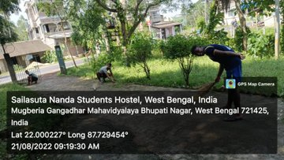
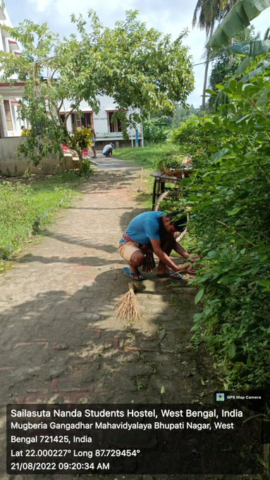
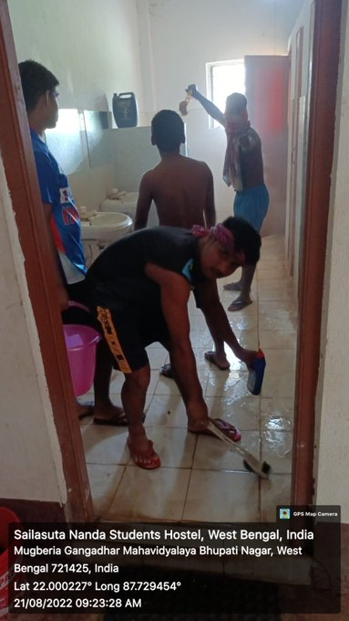
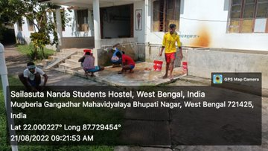

Twitter Link: https://twitter.com/MugberiaM/status/1561360779408187393
2. Observation of 76th Independence Day, organized by NSS, NCC and IIC of the college, dated 15.08.22
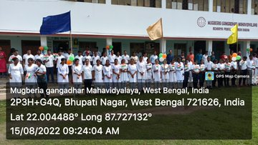
The NSS, NCC and IIC units of the college observed 76th Independence day, 2022 by means of national flag hoisting, morning rally, short cultural function to develop the patriotic mind of the students and to pay homage and to remind the contributions of freedom fighters for our country. About 104 students (M 72, F 32) and 19 faculty members (M 11, F 8) were participated in this program.
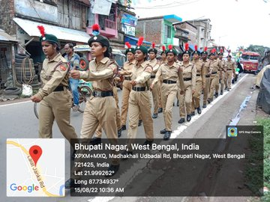
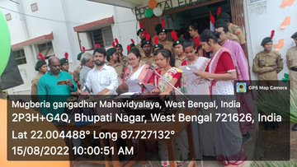
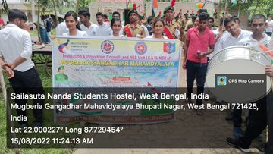
Twitter Links: https://twitter.com/MugberiaM/status/1559565466439335937
https://twitter.com/MugberiaM/status/1559564622742503425
https://twitter.com/MugberiaM/status/1559563094023491585
https://twitter.com/MugberiaM/status/1559209028508536832
3. Rakhi Bandhan Utsab in the college, organized by students union ,dated 12.08.22
The students union of the college observed Rakhi bandhan utsab in collaboration with NSS units of the college on 12.08.22. In this occasion, a rally was arranged in the nearby road and the students wore rakhi to the common people irrespective of age, religion to convey the message of community unity for all round development of the nation. Then a short cultural program was also arranged highlighting the national integration and importance of the day. About 176 students (M 93, F 83) and 17 teachers (M 09, F 08) were participated in this program.
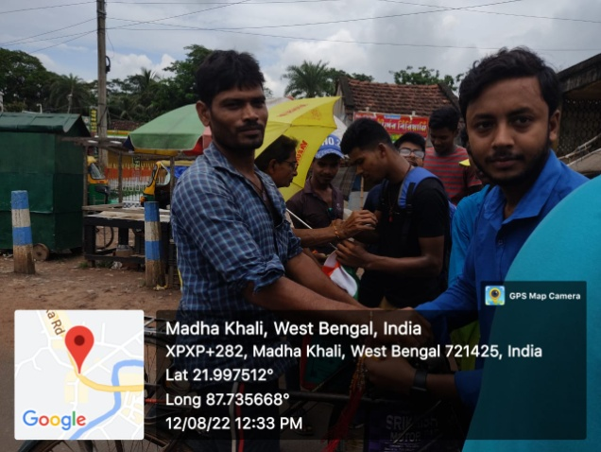
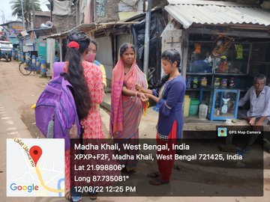

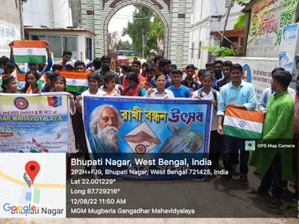
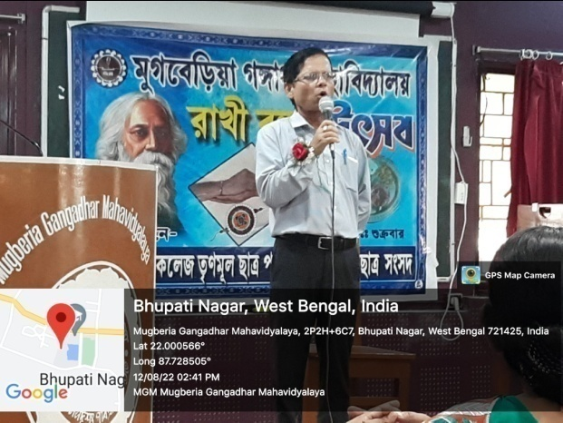

Twitter Links:https://twitter.com/MugberiaM/status/1558358533187727362
https://twitter.com/MugberiaM/status/1558357089004953601

4. Awareness program on Innovation & Entrepreneurship for Aatmanirbhar Bharat on the occasion of celebrating 75 years of Independence- Azadi ka Amrit Mahotsav dated 12.08.22

The IIC of the college along with NSS units had arranged an awareness program on Innovation and entrepreneurship for Atmanirbhar Bharat to encourage the students with a spirit of self-entrepreneurship so that they can be able to self-supported and self-dependent. Around 73 students (Male: 47, Female: 26) and 11 teachers (Male: 7, Female: 4) participated in the program. Our respected Principal Sir, DrSwapan Kumar Misra inaugurated the program.
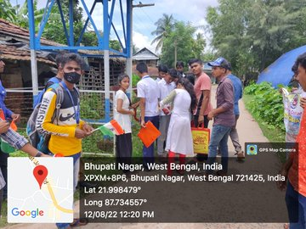
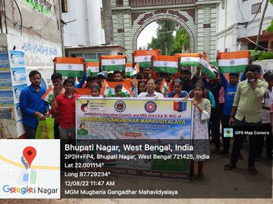

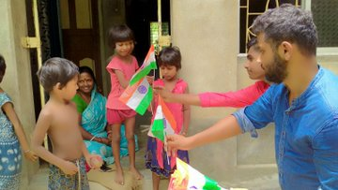
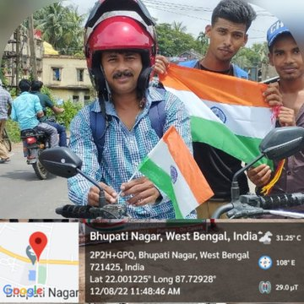

Twitter Links:https://twitter.com/MugberiaM/status/1558287976244711424
https://twitter.com/MugberiaM/status/1558117189047029760

5. Plantation of sapling in our college campus, organized by NCC students of the collegedated 10.08.22
To emphasize the importance of plantation on reducing environmental pollution, the college NCC unit planted saplings in the college campus and also distributed the saplings to the students. About 39 students (M: 25, F: 14) and 9 teachers (M: 5 F: 4) were participated in the program.
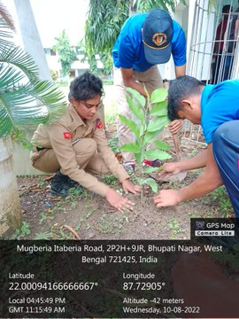
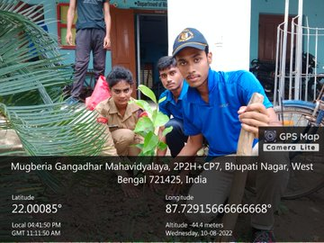
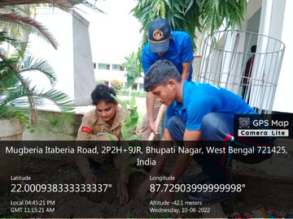
Twitter link: https://twitter.com/MugberiaM/status/1557353369534353410

6. NSS students of the college are engaged to clean the local hospital area, dated 29.07.22
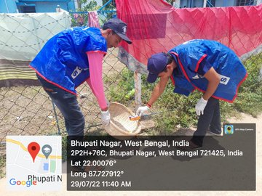
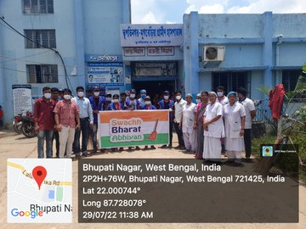
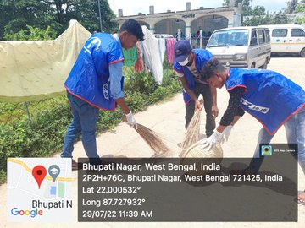
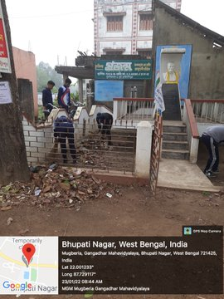
In the initiation of all the NSS units, about 57 NSS cadets (M: 38 F: 19) were engaged in the cleaning program around the local hospital area under the leadership of 3 program officers sensitize the students about volunteer works for the benefit of the society.

Twitter link: https://twitter.com/MugberiaM/status/1553235118482792449
7. Coastal cleaning programme at Dadanpatrabar, Mandarmani, Purba Medinipur organized by Faculty Members of Mugberia Gangadhar Mahavidyalaya in association with NSS units of the college, Dated 20.07.22
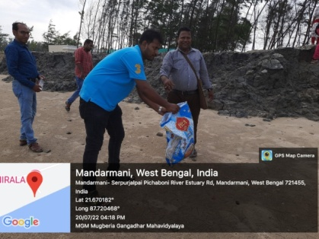
NSS units of the college in association with faculty members organized a one day drive for cleaning the sea beach at Mandarmani, Purba Medinipur to give a message of saving the marine ecosystem for ecological sustainability. The NSS volunteers (M: 31, F: 9) and the teachers (M: 13, F: 3) collected the solid wastes including plastic waste and segregate them into degradable and non degradable packets.
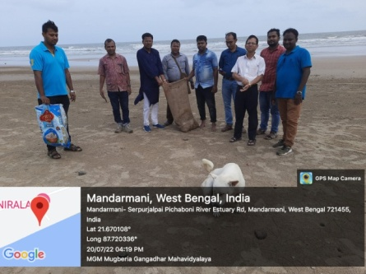
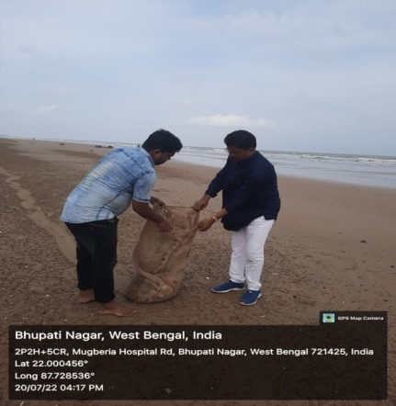
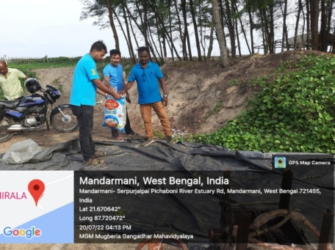
Twitter link: https://twitter.com/MugberiaM/status/1549787967857643520

8. Arannya Saptahya program organized by Department of NSS and NCC of the college amongst nearest Villagers and our students, dated 19.07.22@ugc_india
NSS and NCC units of our college have organized Arannya Saptahya as per UGC notification on 19.07.22 engaging 107 students (M: 85 F: 22) and 37 local villagers (M: 23 F: 14). The program was inaugurated by our Principal Sir followed by short lectures of the guests on the importance of the day, saplings were distributed to local villagers and plantation of saplings were carried out in the college campus.
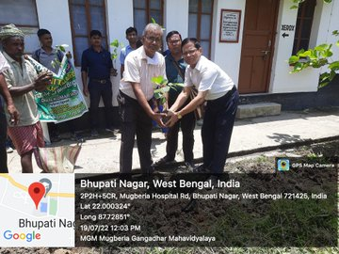
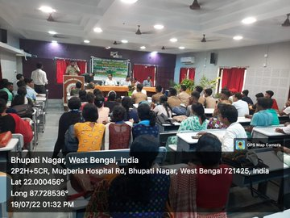

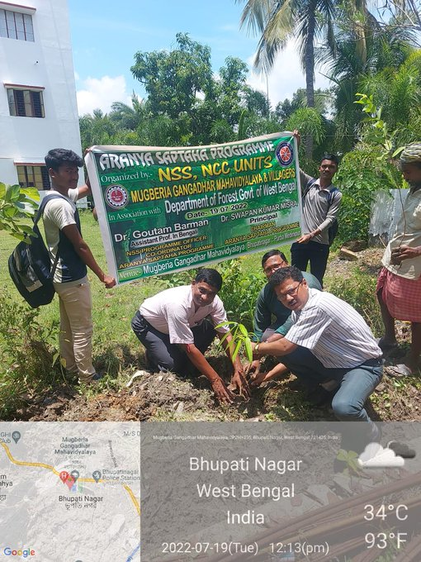
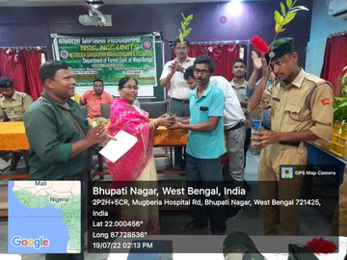

Twitter link: https://twitter.com/MugberiaM/status/1549325282489708544
https://twitter.com/MugberiaM/status/1549323131487064064

9. Observation of International Biodiversity Day, organized by Zoology Department in association with NCC of the college
The Zoology Department in association with NCC of the college observed International Biodiversity Day for awareness to the students regarding Biodiversity, dated 29.12.21. About 15 students and 9 teachers were present.
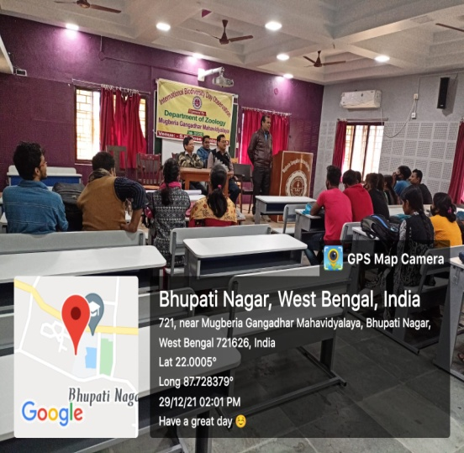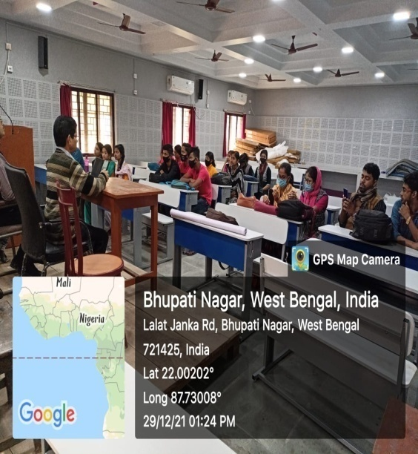
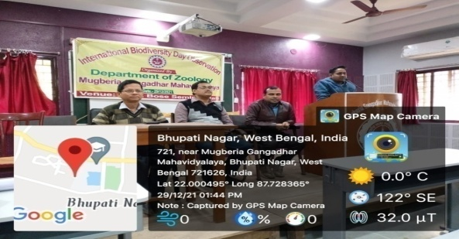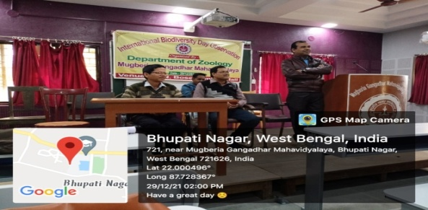
Twitter link: https://twitter.com/i/status/1476414913132122112
https://twitter.com/MugberiaM/status/1476414347400265729/photo/4

10. International Plastic Bag Free Day observed by our NSS units of the college at our adopted village Madhakhali dated 03/07/2022
The NSS units of the college observed international plastic bag free day at road of Madhakhali under Unnata Bharat Abhigyan Program to aware the people about the adverse effects of plastics responsible for environmental pollution and various carcinogenic diseases. As part of this program, Principal sir and Head, Chemistry department delivered lectures on the significance of observing this day and cloth bags were provided to the people present on the market and road at that time. About 49 NSS cadets (M: 33 F: 16) were participated in this road program.

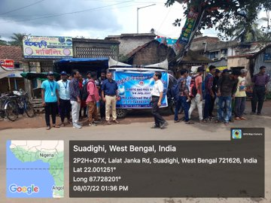
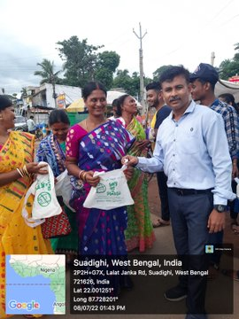
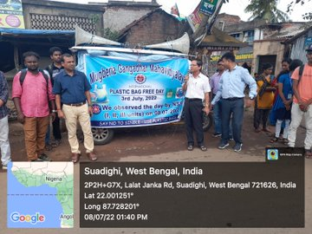
Twitter link:https://twitter.com/MugberiaM/status/1545392489691217920/photo/1
https://twitter.com/MugberiaM/status/1545389153667661824/photo/3
https://twitter.com/MugberiaM/status/1545388726331002881/photo/1

11. Observation of International Day of yoga, organized by Department of Physical Education, NCC and NSS of the college dated 21.06.22
In the initiation of all the NSS, NCC units, department of Physical Education observed International yoga day by means of doing various yogasan, pranayam, free hand exercise etc. About 59 NSS cadets (M: 33 F: 26) were participated in the yoga program under the leadership of 3 program officers to sensitize the students about importance of yoga for the healthy body and mind.
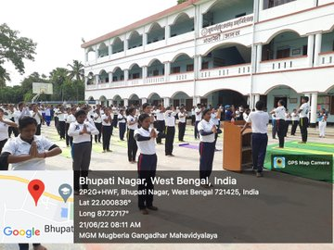
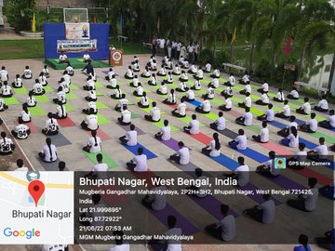

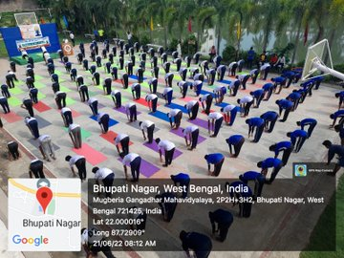
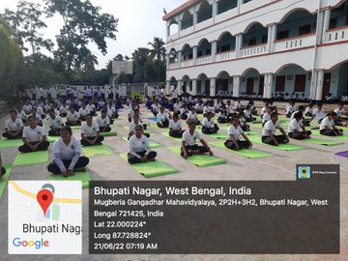
Twitter link:https://twitter.com/MugberiaM/status/1539112553233661952/photo/1
https://twitter.com/MugberiaM/status/1539110488570744832/photo/2
Video Link: https://twitter.com/i/status/1539112810583625730
12. Essay competition on the occasion of International Language Day at MugberiaGangadharMahavidyalayaorganized by IQAC in collaboration with NSS of the college dated 22.02.22
The IQAC of the college organized essay competition among the students on the occasion of international language day in association with NSS units of the college to aware the students about the significance and history of language day observation. About 77 students (M: 55 F: 22) were participated in this program and best three essays are awarded on that day.
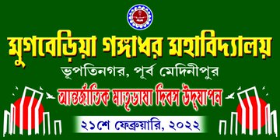
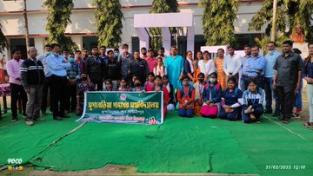

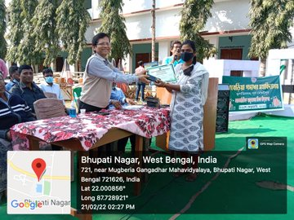
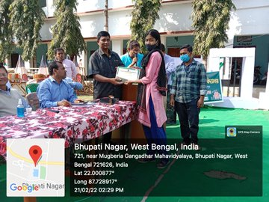

Twitter link: https://twitter.com/MugberiaM/status/1496128168184406018/photo/4
https://twitter.com/MugberiaM/status/1496127713786146822/photo/3
13. Observation of 26th January 2022, the 73rd Republic Day at MugberiaGangadharMahavidyalaya organized by NCC & NSS units of the college
The 73rd Republic day was observed with high enthusiasm by the NSS and NCC students on 26th January, 2022 in the college campus to recapitulate the significance of this day and to pay homage to our democracy first developed by B. R. Ambedkar. About 83 students along with 12 faculty members were present in this program.
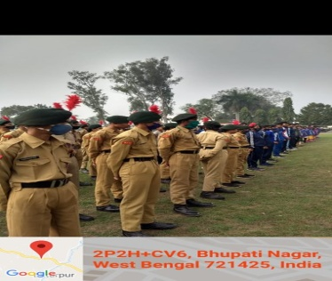
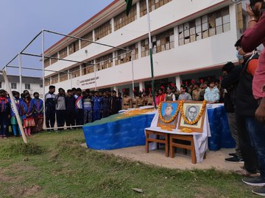

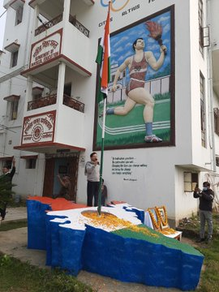
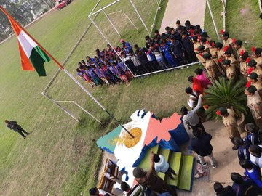

Twitter link:https://twitter.com/MugberiaM/status/1486260708551839749/photo/1
https://twitter.com/MugberiaM/status/1486260470290202628/photo/2
https://twitter.com/MugberiaM/status/1486259290805772291/photo/4
14. Observation of National youth Day, on 12.01.22 organized by NSS of MugberiaGangadharMahavidyalaya
The three NSS units of the college observed National Youth day on the birthday of Swami Vivekananda on 12.01.22 to awake and aware the youth mainly the students about their duties that Vivekananda told towards the youth of India. About 64 students (M: 42 F: 22) were participated in this program. An encouraging online lecture by one Maharaja from Belur Math was also organized on that day.
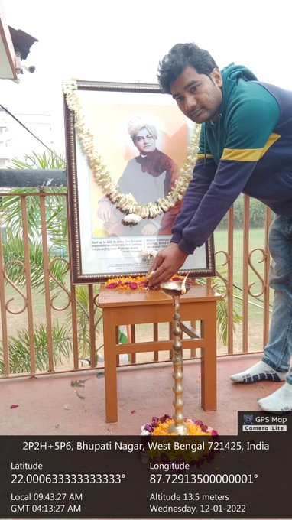
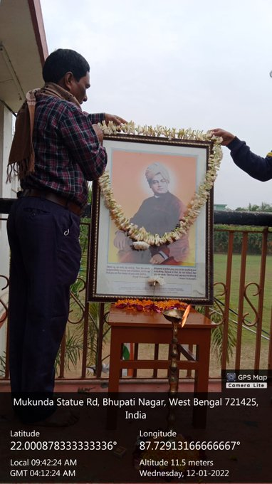

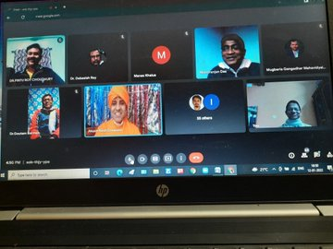
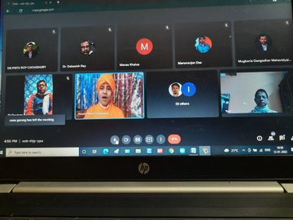

Twitter link: https://twitter.com/MugberiaM/status/1481252273464299522/photo/4
https://twitter.com/MugberiaM/status/1481249742378184707/photo/1

15. Swachhta action plan Activities 2021 - 2022 regarding Toilet in the campus
The NSS units of MugberiaGangadharMahavidyalaya has conducted and coordinatedSwachhta action plan Activities 2021 - 2022 regarding Toilet in the campus with 37 volunteers (M: 22 F: 15).
16. Awareness program through yoga organized by NSS units of the college on their special winter camp on 27.12.21
In the initiation of all the NSS units, about 69 NSS cadets (M: 42 F: 27) were participated in the yoga program of special winter camp under the leadership of 3 program officers to sensitize the students about their health concerns.
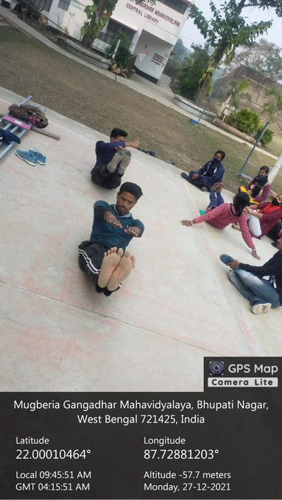
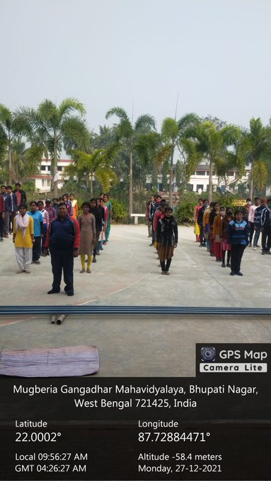

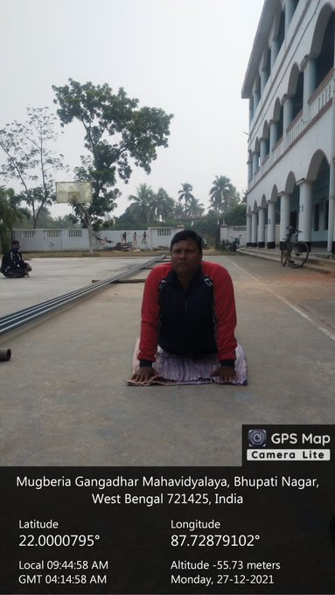
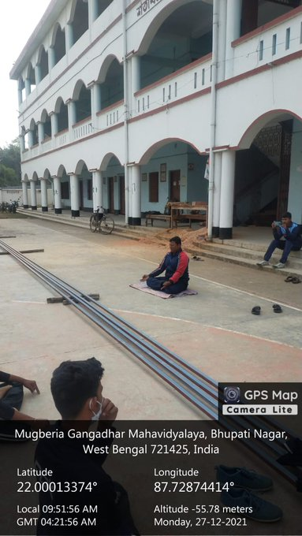

Twitter link: https://twitter.com/MugberiaM/status/1475468238699982848/photo/1
Video link: https://twitter.com/i/status/1475469439256592384
17. Awareness regarding students’ credit card by NSS Volunteers in their special winter camp on 27.12.21
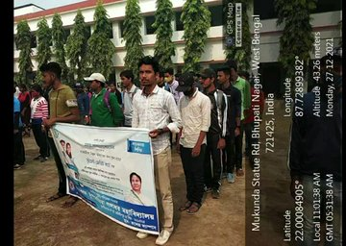
The NSS volunteers in their special winter camp arranged an awareness program related to application procedure, benefits of students’ credit card initiated by Govt. of West Bengal. About 79 participants (M: 56 F: 23) were benefited by the awareness lecture delivered by the Principal Sir.
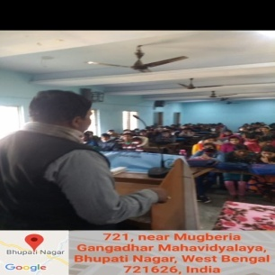
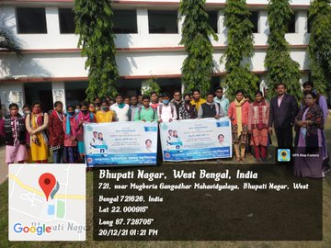

Twitter link: https://twitter.com/MugberiaM/status/1475446973775814657/photo/4
Video Link: https://twitter.com/i/status/1475404848417828865
18. Seminar on 'Necessity of COVID Vaccination' organized by NSS units in their special winter camp, dated 26.12.21
The NSS units of the college organized a seminar on the necessity of COVID vaccination in their special winter camp to convey the message that it is compulsory for all the citizens of India to take COVID vaccination for getting rid of COVID pandemic. About 83 students (M: 44 F: 39) were participated in this seminar. The speaker was DrDebasis Ray, HOD, Physical Education and Sports Science of MugberiaGangadharMahavidyalaya.
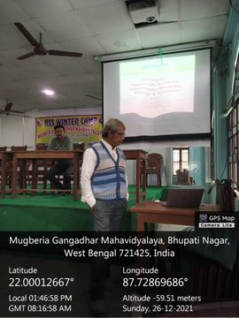
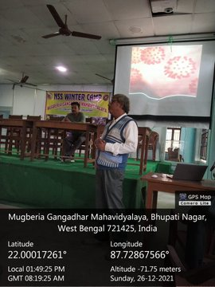

Twitter link: https://twitter.com/MugberiaM/status/1475445428313223175/photo/3
19. NSS Students conducted a survey program on health and sanitation in the nearby village named Bhupatinagar during their special winter camp dated 27.12.21
In the winter camp, the NSS students conducted a survey to the local village to collect information related to health, sanitation, food habits, and professions of the villagers. Not only they collected data but also provide suggestions to the villagers for overcoming their problems what they stated. They collected data from about 30 families.
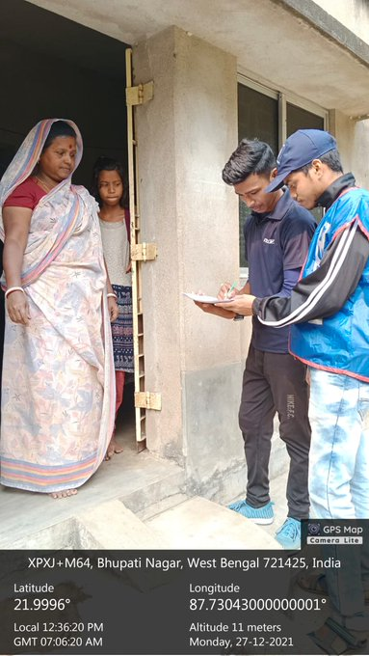
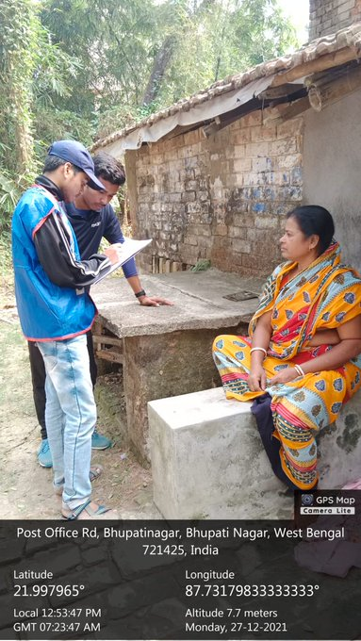
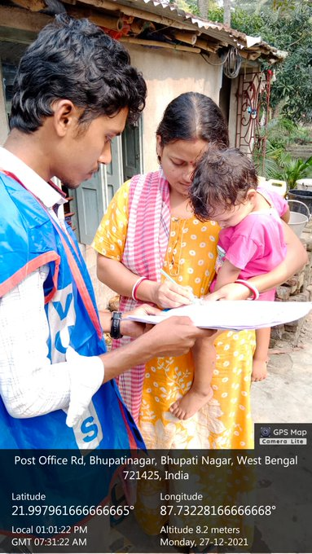

Twitter link: https://twitter.com/MugberiaM/status/1475441992968531976/photo/2
20. NSS units initiated Swachhta actions to maintain Green and clean campus of MugberiaGangadharMahavidyalaya on 24.12.21 in their special winter camp
The three NSS units of the college initiated Swachhta actions to maintain Green and clean campus on 24.12.21 in their special winter camp. About 72 students (M: 42 F: 30) were actively participated in this cleaning the campus program.
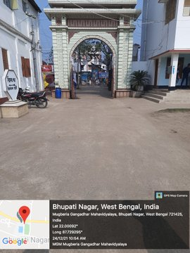
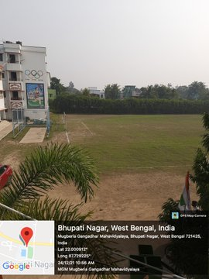
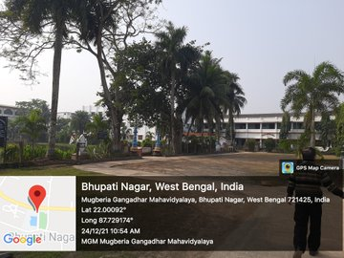

Twitter link: https://twitter.com/MugberiaM/status/1474416421195059207/photo/1
21. NSS special winter camp on and from 23.12.21 to 29.12.21
Like the previous years, the NSS units of the college also organized seven days special winter camp in this 2021-22 session on and from 23.12.2021. The camp was inaugurated be the Principal sir of the college and in the inaugural lecture the principal sir emphasized on the social services that should be rendered by the NSS volunteers to the local areas besides their traditional educations. About 90 students (M: 56 F: 34) were participated in this camp.
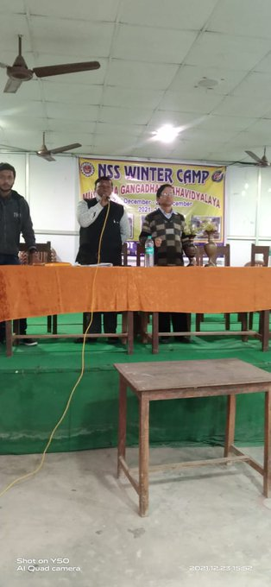
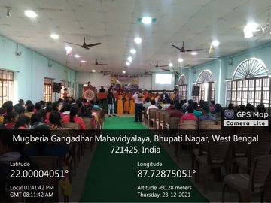
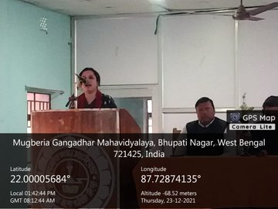

Twitter link: https://twitter.com/MugberiaM/status/1474239275252084738/photo/1
https://twitter.com/MugberiaM/status/1472905097319370752/photo/1
22. Celebration of international AIDS Day dated 01/12/2021
The NSS Units of the college celebrated the international AIDS day in collaboration with Mugberia Rural Hospital on 01/12/2021 in a befitting manner with awareness talk on the public place, road show on awareness, procession with awareness placards and person to person peps talking to sensitize the people with this issue. About 76 students (M: 47 F: 29) were participated in the program.

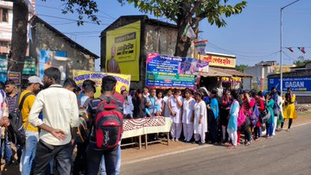
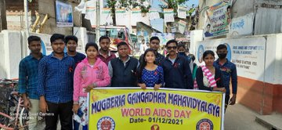
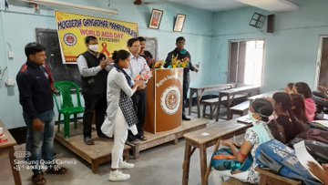

Twitter link: https://twitter.com/MugberiaM/status/1466804375695896579/photo/1
https://twitter.com/MugberiaM/status/1466803811712962568/photo/1

23. New India Blood donation camp dated 24.11.21
Under the leadership of three NSS units of the college as their Red Ribbon club activity organized a campaign named New India Blood donation camp on 24.11.21. About 77 student volunteers (M: 57 F: 20) donated blood in this program. The NSS officers conveyed the message of importance of blood donation in their lectures.
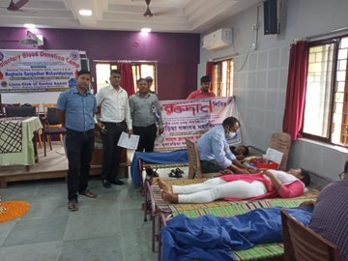
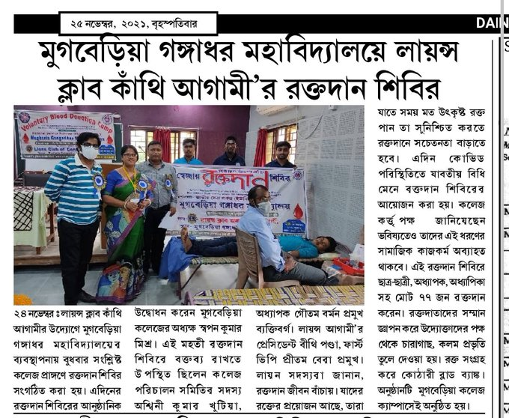

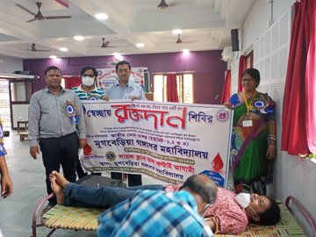
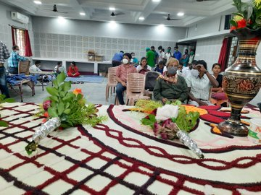

Twitter link: https://twitter.com/MugberiaM/status/1463913156091125771/photo/1
https://twitter.com/MugberiaM/status/1463818398752665602/photo/3
https://twitter.com/MugberiaM/status/1463806344121573378/photo/4
https://twitter.com/MugberiaM/status/1463805462659223557/photo/3
https://twitter.com/MugberiaM/status/1463804571109650434/photo/1
24Flood relief program by NSS Volunteers of the college on 02.10.21, 08.10.21 and 09.10.21 to the local villages
During the dread flood in the month of October, 2021, the vast areas of Bhagwanpur II Block were under flooded water for about two months. In this period, the NSS student volunteers about 20 on an average and students of UnnatabharatAvijan(about 10) along with Principal Sir and other faculty members rendered their volunteer services to the people by supplying dry foods, drinking water, medicines and also by providing cooking foods to the people who were in the shelter of college premises. By rendering these services they are sensitized about these disaster management issues of the society.
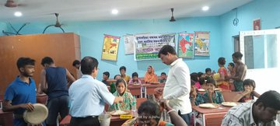
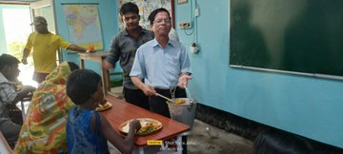
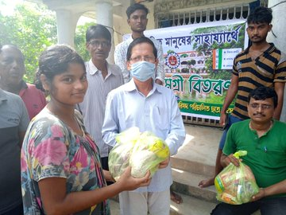
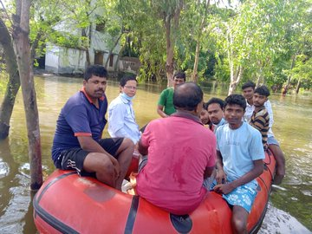
Twitter link: https://twitter.com/MugberiaM/status/1447613353728245761/photo/1
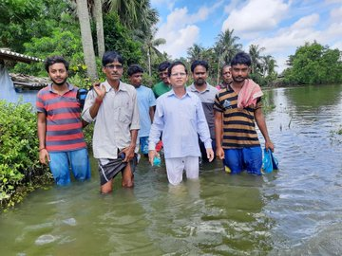
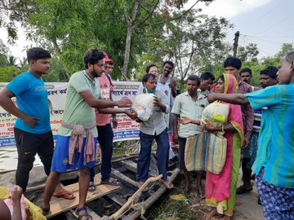
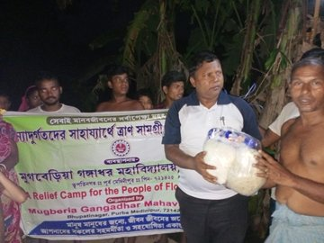
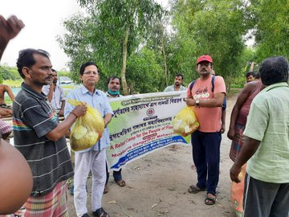
https://twitter.com/MugberiaM/status/1446491020959518724/photo/1
https://twitter.com/MugberiaM/status/1445397784702619653/photo/2
https://twitter.com/MugberiaM/status/1445395505689899024/photo/4
https://twitter.com/MugberiaM/status/1445394489963687942/photo/1

25. One day State level webinar on Gandhi's Theory and Practice and Contemporary Relevance,organized by NSS and IQAC of the college dated 02. 10. 2021
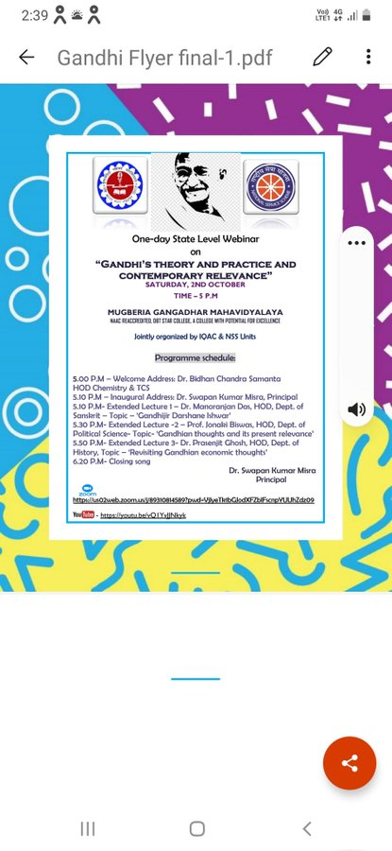
The NSS units in collaboration with IQAC organized a one day State level webinar on Ganbhi's Theory and Practice and Contemporary Relevance on the occasion of Gandhi’s Birthday dated 02/10/21. This webinar was inaugurated by our respected Principal Sir and he delivered his valuable address by stating the significance of this day observation. The IQAC coordinator of the college described the theme of the webinar in details. About 93 participants (M: 63 F: 30) were present in the online platform.

Twitter link: https://twitter.com/MugberiaM/status/1444591624592314371/photo/1
26A state level Webinar, dated 26.09.21 organized by IQAC and NSS of the college on the 201 birthday of PanditIswar Chandra Vidyasagar

In association with IQAC of the college, the NSS units organized this online seminar to celebrate the birthday of PanditIswar Chandra Vidyasagar by discussing the life, social reforms and contributions on women education of Vidyasagar in India so that students can be sensitize about the glorious social works done by this great person. About 75 participants (M: 42 F: 33) were present in the online platform.
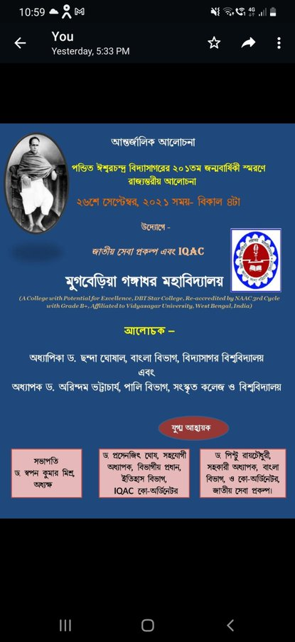

Twitter link: https://twitter.com/MugberiaM/status/1442543135607820288/photo/1
27. One day State Level Webinar on Importance of Covid - 19 Vaccination to observe NSS Day on 24th September 2021
The NSS units of the college observed NSS day by means of an online seminar on Importance of Covid - 19 Vaccination to aware the students about significance of compulsory taking COVID vaccine to get rid of the pandemic caused by corona virus. About 81 participants (M: 52 F: 29) were present in the online platform. The speakers also described the importance of NSS day in this program.
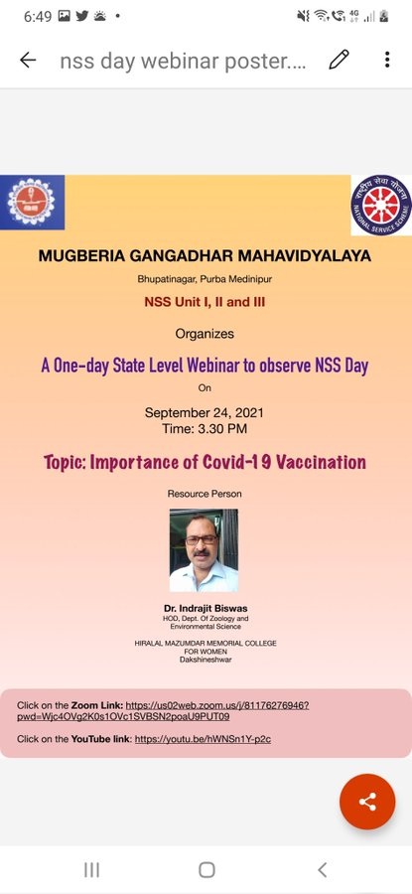

Twitter link: https://twitter.com/MugberiaM/status/1441436766280433665/photo/1
28. Plantation program on the eve of ArannyaSaptahya on 26.07.21 organized by NSS units of the college
Like the previous years, the NSS units in collaboration with PurbaMedinipurZilaParisad organized plantation program in the college premises on the occasion of celebrating ArannyaSaptahya throughout the state. Various fruit saplings were planted in college premises and also supplied the saplings to the students present in this program by cloth bags instead of plastics. The students were motivated to give more importance on the plantation to reduce environmental pollution. About 58 participants (M: 31 F: 27) were present in the program.
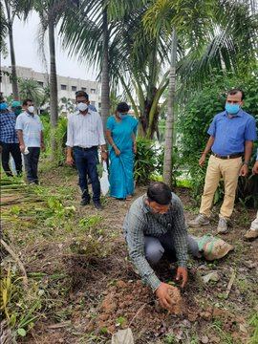
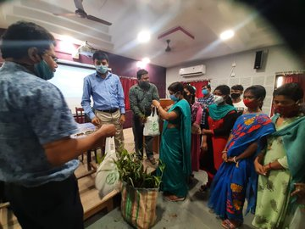

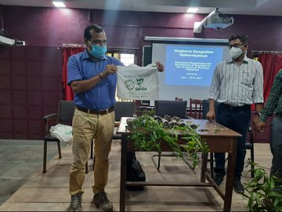
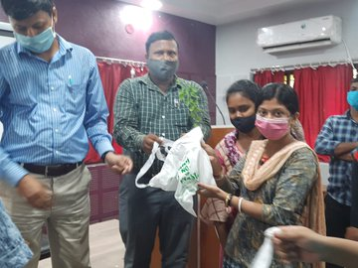

Twitter link:https://twitter.com/MugberiaM/status/1419599194122194947/photo/4
https://twitter.com/MugberiaM/status/1419598275074617344/photo/1

